ODE Mathematics Pathways

ODE Mathematics Pathways: Proposed Changes and Concerns
The Oregon Department of Education (ODE) has proposed significant changes to the state's mathematics sequence, affecting students' math education from middle school through high school. Below is a summary of the key points, along with concerns raised about the implications of these changes.

Key Changes in the Math Sequence
- Heterogeneous Math Classes
  - All students will remain in untracked, heterogeneous math classes through middle school until 11th grade.
- Introduction of Three Pathways in High School
After 10th grade, students can choose one of three pathways:
  - Quantitative Reasoning (e.g., construction geometry, financial algebra; akin to vocational tracks).
  - Data Reasoning (e.g., data science, statistics, and other data-focused courses).
  - Calculus (Algebra 2, pre-calculus, calculus).
- Modifications to the Curriculum
  - All pathways are the same through 10th grade.
  - Geometry is reduced by half a year and replaced with “data reasoning.”
  - Only the calculus pathway includes Algebra 2.
- Impact on Advanced Math Students
  - Students aiming for calculus or AP Calculus must take extra steps:
    - Doubling up on math courses during high school.
    - Taking summer or distance learning courses.
    - Combining Algebra 2 with pre-calculus.
  - This plan discourages advanced math participation, potentially leading to insufficient enrollment for calculus classes.

The ODE issued a grant to create a High School Math Pathways Communication Toolkit
to explain their recommendations.

Concerns about the Toolkit
General Concerns
- The revised sequence does not meet the needs of academically advanced students, especially those in the TAG (Talented and Gifted) program.
- Piloting districts have reportedly eliminated middle school algebra for all students, which contradicts research and frustrates students.

Equity and Misleading Claims
- Toolkit’s Equity Argument
  - The ODE's Toolkit claims that keeping advanced students in general education classrooms fosters equity.
  - However, some research suggests the opposite:
    - Research evidence:
      - “What One Hundred Years of Research Says About the Effects of Ability Grouping and Acceleration on K–12 Students’ Academic Achievement” (Steenbergen-Hu et al.)​.
      - Articles from the Brookings Institution and the Fordham Institute challenge the assumption that “detracking” benefits all students equally​.
- Misleading Responses to Parent Concerns
The Toolkit instructs administrators to address parental concerns with questionable claims. Examples include:
  - On calculus and college admissions:
    - Toolkit: Calculus is losing status in college admissions. “Many higher ed institutions in the US, including elite private colleges like Harvard and Standford, have made strong admissions statements that they will not privilege Calculus over courses like Statistics and Data Science. ….”
    - Reality: Elite colleges still value calculus and do not accept “data science” as a substitute.
  - On TAG student needs:
    - Toolkit: “We are redesigning math classes to include rich, modern learning that benefits all students.”
    - Reality: The curriculum doesn’t sufficiently challenge advanced students.
  - On college course acceptance:
    - Toolkit: “Starting in 2024, Algebra 2 won’t be required for admission to Oregon public colleges.”
    - Reality: Students without Algebra 2 will struggle in college and STEM programs in most universities. They won’t discover that they were misled until too late.
- Impact on First-Generation College-Goers
  - Misleading claims especially harm families with less experience navigating college admissions and perpetuate the very inequality the “Pathways” intend to reduce.

- Impact on Engagement
- Educated parents are less likely to trust schools when they perceive inaccuracies.

Research Misrepresentation
- The Toolkit misrepresents research to justify its recommendations:
  - Example: The Toolkit cites Card & Giuliano's studies to claim that mixed-ability classrooms benefit everyone.
  - Actual findings: Card & Giuliano's research* found that separate classrooms for high-achieving students benefit low-income and minority students the most (see excerpts below)​.

Broader Implications
- College and Career Readiness
  - Students discouraged from taking Algebra 2, pre-calculus, or calculus will find themselves unprepared for University requirements or STEM careers.
  - This will handicap Oregon students, especially students from underserved communities.
- Trust and Transparency
  - The perception that schools dismiss parental concerns as uninformed or prejudiced undermines trust between families and schools.

Conclusion
While the ODE’s proposal aims to promote equity, its approach reduces opportunities for advanced students and fail to adequately prepare them for college or STEM careers. There’s a need for:
- Clearer communication with families about the implications of these changes.
- Alternative sequences for TAG and advanced students.
- Accurate representation of research to support policy decisions.

Pathways chart from the Executive Summary, page 9

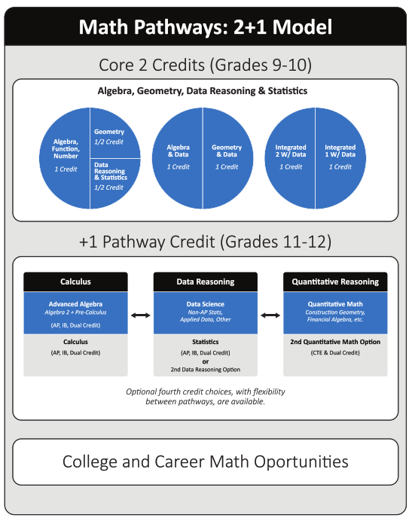

- *Card and Giuliano (2016)"Can Tracking Raise the Test Scores of High-Ability Minority Students?"
"We evaluate a tracking program in a large urban district where schools with at least one gifted fourth grader create a separate 'gifted/high achiever' classroom. Most seats are filled by non-gifted 'high achievers,' ranked by the previous year test scores…. We find significant effects that are concentrated among black and Hispanic participants. *Minorities gain 0.5 standard deviation units in fourth-grade reading and math scores, with persistent gains through sixth grade. We find no evidence of negative or positive spillovers on non-participants." [my emphasis]
- *Card and Giulano: "Does Gifted Education Work? For Which Students?" (2014)
Abstract: "..... We use data from a large urban school district to study the impacts of assignment to separate gifted classrooms on three distinct groups of fourth grade students: non-disadvantaged students with IQ scores ≥130; subsidized lunch participants and English language learners with IQ scores ≥ 116; and students who miss the IQ thresholds but scored highest among their school/grade cohort in state-wide achievement tests in the previous year. Regression discontinuity estimates based on the IQ thresholds for the first two groups show no effects on reading or math achievement at the end of fourth grade. In contrast, estimates based on test score ranks for the third group show significant gains in reading and math, concentrated among lower-income and black and Hispanic students. The math gains persist to fifth grade and are also reflected in fifth grade science scores. Our findings suggest that a separate classroom environment is more effective for students selected on past achievement – particularly disadvantaged students who are often excluded from gifted and talented programs

